What Are AI Hallucinations? Fake Facts with Real Consequences

# Introduction: Can You Really Trust AI?

Artificial intelligence is supposed to be the future of knowledge, right? So why is it confidently handing out fake facts like a know-it-all with no receipts?

From legal advice to medical suggestions, AI models like ChatGPT and Claude are often trusted to deliver accurate information in seconds. But here’s the problem: *sometimes they just make things up*—completely fabricated names, sources, or historical events—all delivered with the confidence of a tenured professor.

These moments are called *AI hallucinations,* and while they might sound like a glitch in a sci-fi movie, they’re very real—and increasingly common. In some cases, they’re harmless. In others, they’ve already caused professional embarrassment, legal mishaps, and serious trust issues.

In this article, we’ll break down what AI hallucinations are, why they happen, and how to spot them before they lead you astray. Because in the world of artificial intelligence*, sounding smart doesn’t always mean being right.*

# What Are AI Hallucinations?

AI hallucinations happen when an artificial intelligence model gives you an answer that’s false, misleading, or completely invented, yet sounds totally believable.

*Example:*  
You ask ChatGPT: “Who invented Bluetooth?”  
It replies: “Steve Jobs in 2001.”  
That’s incorrect—but the answer sounds confident, so many people believe it.

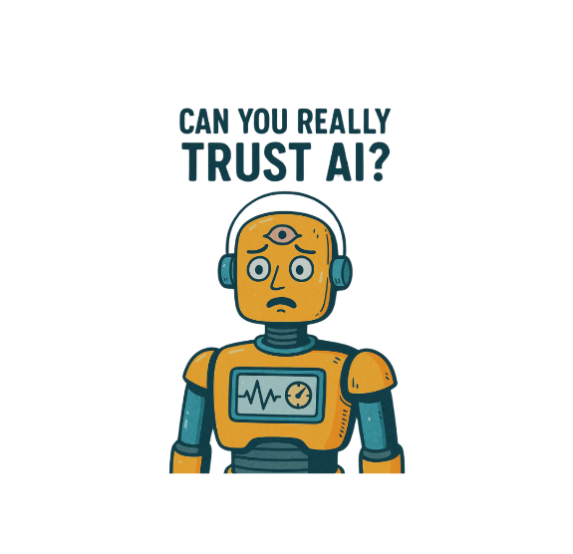

# Why Do AI Hallucinations Happen?

Understanding why AI tools hallucinate helps you use them more safely. Here are a few key reasons:

**1. AI Predicts, It Doesn’t Understand**

Large Language Models (LLMs) like ChatGPT or Claude don’t “know” things in the human sense. They aren’t accessing a live encyclopedia or database. Instead, they’ve been trained on huge amounts of text and learn statistical patterns—they predict what word or phrase comes next based on previous words.

Think of it like autocomplete on steroids—the AI doesn’t truly understand context, meaning, or truth; it just knows what sounds statistically likely.

This means it can generate incredibly fluent, persuasive answers that have no grounding in reality. The confidence comes from linguistic fluency, not from fact-checking or comprehension.

**2. Missing or Outdated Training Data**

Most AI models are trained on a fixed dataset with a cutoff date. For example, many versions of ChatGPT were trained on data up to April 2023 or earlier. If something happened after that, the model simply doesn’t know about it.

Additionally, gaps in the training data mean the model may have never seen the correct answer at all. In these cases, it does what it’s designed to do: make a statistically likely guess. This often results in:

* Mixing up facts (like attributing quotes to the wrong person),
* Combining unrelated information, or
* Reconstructing facts in plausible but incorrect ways.

*Example:* An AI might confidently say that a software library has a certain feature—because *most* similar libraries do—even if it doesn't.

**3. Poor Prompt Framing**

The way you ask a question significantly impacts the answer an AI gives. If the prompt is vague, biased, or overly complex, the AI may try to “fill in the gaps” by guessing what you're asking—and this is often where hallucinations slip in.

For example, asking: *“What court cases prove pineapple is illegal in California?”* assumes the premise is true—even if it's absurd. The AI might hallucinate cases to support your question instead of correcting you.

This happens because many language models are optimized to be helpful and cooperative—even if the prompt is misleading. Without context correction, they tend to “play along” with the framing.

**4. No Real-Time Fact-Checking**

LLMs are not live search engines. Most models do not have internet access or real-time fact-checking unless explicitly connected to external tools.

They can’t:

* Look up live news,
* Confirm dates or prices, or
* Check current laws or policies.

Without grounding in real-time or external data sources (like a verified database or search API), the AI simply generates content based on past training. If you ask it for a source or a URL, it may invent one—because generating text is all it knows how to do.

Some newer AI systems try to mitigate this by combining retrieval-augmented generation (RAG) techniques, where the model pulls real-time documents and generates a response based on them—but even then, accuracy is not guaranteed unless the tool is explicitly designed for reliability (like Perplexity AI or Bing Chat with citations).

**Real Examples of AI Hallucinations**

AI hallucinations aren’t just theoretical—they happen all the time in real-world settings:  
- *Legal Hallucinations:* A lawyer used ChatGPT to cite fake court cases in a real lawsuit.  
- *Medical Errors:* Some AI chatbots have suggested incorrect medication dosages.  
- *Fake Citations:* Students and researchers have received AI-generated sources that don’t exist.  
- Image Hallucinations: Tools like Midjourney have generated photos of “events” that never happened.

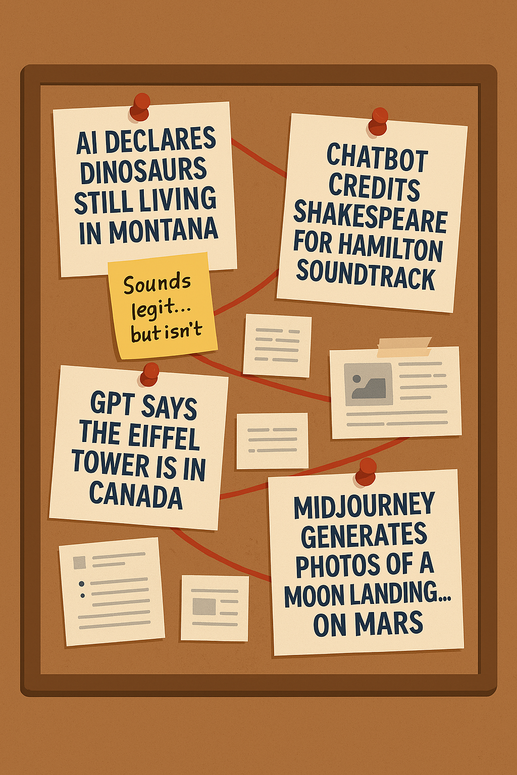

# Why AI Hallucinations Can Have Real-World Consequences

# While many AI hallucinations are harmless - like recommending fictional TV shows or misquoting song lyrics - others can have more serious consequences depending on how and where the AI is being used. The goal isn’t to stop using AI, but to use it responsibly and thoughtfully.

# Here’s how hallucinations can affect different fields—and why users need to stay alert.

# Healthcare: Wrong Medical Advice or Diagnoses

# AI tools are often used to summarize health information or explain symptoms in plain language. However, if the model provides inaccurate medical advice or misdiagnoses a condition, the risks include:

# Delaying a visit to a qualified healthcare provider

# Taking incorrect medications or dosages

# Making decisions based on misinformation, which could lead to harm

# Use AI for general understanding, not as a substitute for professional medical care.

# Legal: Fake Precedents, Laws, or Case Citations

# There have been real cases where lawyers submitted fake citations generated by AI. In legal settings, hallucinations can lead to:

# Case dismissal or rejection of filings

# Professional or ethical violations

# Loss of trust between attorneys and clients

# AI can help explain legal terms or structure a brief, but all legal facts must be verified with trusted legal databases.

# Education: Incorrect Facts in Essays or Assignments

# Students using AI to help write essays or reports may unknowingly submit incorrect facts, false sources, or flawed reasoning. This can result in:

# Reduced grades due to factual errors

# Accusations of academic dishonesty

# A lack of understanding if students rely entirely on the AI’s version of events

# AI is a useful writing partner, but students should always review and fact-check their work

# Journalism: Misinformation in Articles or Reports

# Journalists under deadline might use AI to assist with drafts or fact summaries. But if the AI introduces hallucinated quotes, fake statistics, or invented events, the fallout can include:

# Publishing misinformation to a wide audience

# Damage to a publication’s credibility

# Legal and reputational risk

# AI can help with outlining or summarizing, but everything must be verified before publication.

# Business: Poor Decisions Based on Made-Up Data

# Businesses are increasingly using AI to support market research, draft proposals, or create customer communications. Hallucinated data can lead to:

# Incorrect pricing or investment decisions

# Flawed competitive analysis

# Loss of credibility in public-facing content

# AI is a time-saving tool, but final decisions should always be based on verified data.

# How to Spot AI Hallucinations

# AI tools are great at sounding confident—but that doesn’t mean they’re always correct. In fact, one of the easiest ways to get misled is by assuming the AI’s tone equals truth. Here’s how to become a more skeptical, informed user and reduce the risk of acting on hallucinated information.

# 1. Double-Check Facts with Trusted Sources

# Always confirm important information using reliable, external references. AI may generate statements that sound plausible but are not backed by verified data.

# Use sources like:

# Google Scholar for academic topics

# Government websites (e.g., cdc.gov, irs.gov)

# Official product documentation (e.g., AWS docs, software manuals)

# Reputable news organizations or industry journals

# *Example:* If an AI tells you that a new tax law was passed last month, verify that on your state or federal government website.

# 2. Ask the AI Follow-Up Questions

# One way to test whether an AI response is grounded in fact or just generated is to ask it to explain itself.

# Try follow-ups like:

# “Can you cite your source?”

# “Where did you find that information?”

# “What’s an example of that in the real world?”

# *Watch for signs of hallucination:* If the AI responds with vague or clearly made-up sources, or can’t explain its answer logically, it may have fabricated part of the response.

# 3. Look for Specific Details—Then Check Them

# Hallucinations often contain small inaccuracies that can snowball into bigger problems. Keep an eye on details like:

# Names of people or organizations

# Statistics or data claims

# Historical dates or timelines

# Technical specifications

# Example: If ChatGPT says, “Python 4.0 was released in 2023,” pause and fact-check—because it wasn’t.

# When in doubt, search the details independently or check the official websites tied to the claim.

# 4. Use Real-Time, Web-Connected AI Tools

# Most hallucinations occur when AI tools are working off static training data. To reduce risk, consider using models that can reference real-time sources.

# Reliable tools include:

# Bing Chat with citation support

# Perplexity AI (great for linked sources)

# You.com, which cites search results directly

# Google’s AI tools, when available in connected mode

# These models tend to provide links or references to real documents, helping you verify claims immediately.

# 5. Compare Multiple AI Responses

# If you’re not sure whether a response is valid, try asking the same question in different ways—or use multiple AI tools to cross-reference answers.

# *Example:* Ask both ChatGPT and Bing Chat the same question. If one gives a citation and the other doesn’t, use that as a signal to verify further.

# The more consistent the answers across tools, the higher the likelihood they’re accurate—though you should still verify anything important.

# 6. Trust Your Gut—And Your Domain Knowledge

# Sometimes hallucinations “feel off.” If something sounds suspicious, overly simplified, or just too good to be true, it might be worth a second look.

# *Tips:*

# Be especially cautious with names, laws, citations, and emerging topics.

# If you’re in a specialized field (tech, healthcare, law, etc.), don’t assume the AI “gets it.”

# Flag anything that sounds polished but doesn't quite fit your understanding.

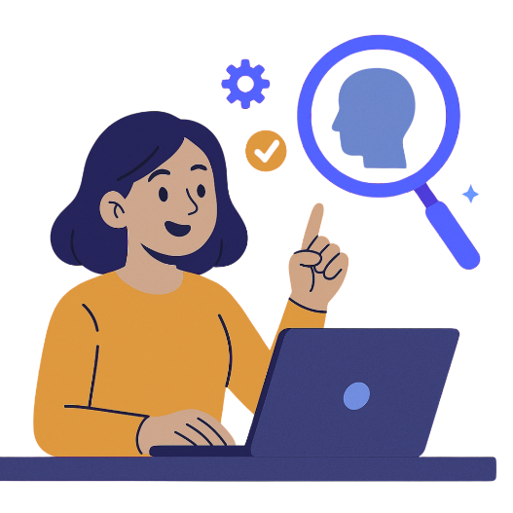

# What Developers Are Doing to Fix AI Hallucinations

# AI hallucinations aren’t being ignored by researchers or developers—in fact, they’re one of the most important and hotly studied problems in the AI community. While hallucinations can’t be eliminated entirely (yet), several promising solutions are being explored to reduce their frequency and severity.

# Here’s a closer look at the most effective strategies being used today:

# 1. Retrieval-Augmented Generation (RAG)

# This technique connects an AI model to an external database or document source (like Wikipedia, product manuals, or research papers) and retrieves real documents in real time to “ground” its responses.

# Rather than guessing based on training data alone, the model reads from reliable sources before responding. It’s like giving the AI a set of notes to refer to before answering your question.

# *Use case:* Tools like Bing Chat, Perplexity AI, and some enterprise-level copilots use RAG to provide more factual, link-backed answers.

# 2. Fact-Checking Layers

# Some systems now add an extra step after the model generates a response, where another process evaluates the factual accuracy of the content. This might include comparing the output to trusted databases or flagging unlikely claims.

# In some cases, tools even highlight or annotate uncertain statements - so the user knows what might be unverified.

# *Use case:* Some news organizations are experimenting with automated fact-checking layers for AI-generated drafts.

# 3. Fine-Tuning with Domain-Specific Data

# General-purpose AI models are more likely to hallucinate when dealing with niche topics. To address this, companies are fine-tuning models with high-quality, industry-specific datasets, such as legal case law, financial regulations, or clinical guidelines.

# This helps the model stay “in-bounds” when responding in those fields, improving accuracy and reducing risk.

# *Use case:* Healthcare companies fine-tuning models with HIPAA-compliant medical data, or legal research tools using verified case law only.

# 4. Confidence Scoring and Uncertainty Awareness

# Some AI systems now include internal confidence scores that help them judge how sure they are about a given answer. When confidence is low, the model can either:

# Warn the user ("I’m not certain about this answer"), or

# Decline to answer altogether

# This “know what you don’t know” approach is an emerging trend to make AI outputs more transparent and responsible.

# *Use case:* Enterprise copilots that handle sensitive business data often use confidence scoring to reduce liability.

# 5. Chain-of-Thought and Step-by-Step Reasoning

# AI hallucinations often happen when a model tries to leap to a conclusion too quickly. A newer technique called chain-of-thought prompting encourages the model to explain its reasoning in steps, which not only improves accuracy but also makes the logic easier to verify.

# *Use case*: Math problem solvers and coding assistants often use this method to break down multi-step problems.

# 6. Human-in-the-Loop (HITL) Systems

# In critical applications—like healthcare, legal, or financial advice—AI outputs are passed through a human reviewer before reaching the end user. This slows things down but ensures accuracy where it matters most.

# *Use case:* AI drafting an insurance report that is then reviewed by a licensed underwriter before final approval.

# 7. Limiting AI Output Scope with Guardrails

# Developers can “box in” models by restricting them to a defined domain or dataset. Instead of letting the AI answer any question freely, it’s trained or configured to only answer based on verified sources or defined topics.

# *Use case:* An internal company chatbot that only pulls from HR documents and policy handbooks.

# Final Thoughts: Use AI, But Use It Wisely

# AI is one of the most powerful tools we’ve ever created. It can brainstorm ideas, write articles, answer complex questions, and even explain string theory in the tone of a pirate (yes, really). But for all its capabilities, AI still has one major flaw: it doesn’t know when it’s wrong.

# Hallucinations remind us that artificial intelligence, no matter how advanced, is still just a pattern generator with a confidence problem. It doesn’t have beliefs, understanding, or a fact-checking engine—it has training data and probability.

# That doesn’t mean we should fear it or avoid it. It means we should use it the same way we’d use any assistant:

# Smart enough to help.

# Fast enough to save time.

# Not quite ready to run the show alone.

# So go ahead—let AI draft your outlines, summarize your PDFs, or help you find that recipe you forgot to save. Just remember to read it twice, Google it once, and never let your chatbot replace your brain.

# Because at the end of the day, AI works best when there’s still a human in the loop - preferably one who knows that Bluetooth wasn’t invented by Steve Jobs.



***Want More Like This?***

If you find this helpful, share it with a friend or bookmark it for later. Next time, we’ll explore: “How to Write Better Prompts to Reduce AI Mistakes”. Stay tuned!